In CMOS detectors, each individual photosensor or more typically each column of photosensors has an amplifier associated with it. A row of pixels can be readout in parallel with the row selected by an addressing register or an individual pixel can be selected by column multiplexer. A CMOS device is essentially a parallel readout device and therefore can achieve higher readout speeds particularly required by imaging applications. CMOS detector technology however still needs considerable development to compete against CCD for performance in scientific applications. To achieve the parallel readout the CMOS amplifier uses multiple amplifiers, each with its own gain, linearity and noise performance variation. Compensating for the variations in the current state of the art CMOS devices is difficult over a wide range of illumination levels and to the accuracy required by scientific applications. High speed readout with high sensitivity can be achieved by EMCCD cameras.
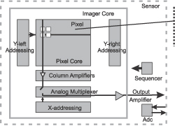
Adding vision to your projects needs not be a difficult task. Whether its machine vision for robot control or the sampling and storage of images for security, CMOS images sensors can offer many advantages over traditional CCD sensors. Just some of the technical advantages of CMOS sensors are,
- No Blooming  - Low power consumption. Ideal for battery operated devices  - Direct digital output (Incorporates ADC and associated circuitry)  - Small size and little support circuitry. Often just a crystal and some decoupling is all that is needed.  - Simple to design with. | 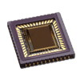

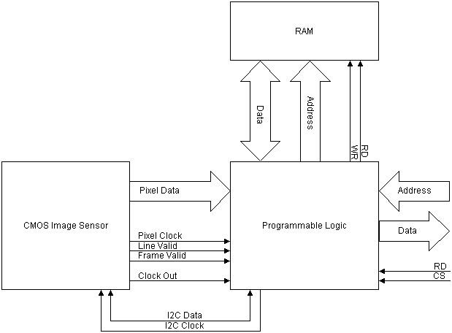
By using a CPLD/FPGA and RAM, you can program the CPLD to dump the data straight into RAM. Your micro could then read this RAM through the PLD which could be memory mapped. If you really want performance (And budget is not a problem), you could use Dual Port RAM. If however you only want to capture one frame, then the PLD could copy one frame into memory and ignore subsequent pixel data until an event such as when your device has read all the data out of RAM. Other options are to use a LVDS (Low Voltage Differential Signalling) serial bus, to relay your data over a few metres or more. At a high enough clock rate, you won't wait all day for a frame.
The other thing you must not forget is how to control the sensor. Most of it's internal parameters are controlled by a serial bus, typically I2C for the majority of sensors. This can either be controlled through a memory mapped Register programmed into your PLD or via an I2C port straight from your uC.

